Project Title* (use style: paper title)

*Note: Sub-titles are not captured in Xplore and should not be used

Student Naem  
Student NumberSupervisor Name  
Programme of study

*Abstract*—This electronic document is a “live” template and already defines the components of your paper [title, text, heads, etc.] in its style sheet. *\*CRITICAL: Do Not Use Symbols, Special Characters, Footnotes, or Math in Paper Title or Abstract*. (*Abstract*)

Keywords—component, formatting, style, styling, insert (key words)

# Introduction (*Heading 1*)

The implementation of lockdown protocols by the United Kingdom Government on 26th March 2020 created a unique environment by restricting movement among non-essential workers and limiting social contact (Johnson, 2020). The primary reason was to reduce the spread of the disease and ease the burden on the National Health Service. However, the effects of this lockdown spread to all sectors, including hospitality, construction, education, travel, and the judicial system (ONS, 2020). From March 26th 2020 lockdown measures legally came into force and the UK police were given extra enforcement powers to reduce the spread of coronavirus, including the ability to instruct members of the public to return home or leave an area (UK Gov, 2020). The lockdown required non-essential shops such as pubs and retail stores to close and for non-essential workers to work from home if possible. Those that could not work from home were furloughed, with one in four people that had been employees having been on furlough at some point between March 2020 and June 2021 (ONS, 2021). Table 1 contains a full timeline of lockdown events from the beginning of lockdown on March 26th 2020 to the end of the third and final lockdown on July 19th 2021. These restrictions resulted in changes to the mobility of the general public to the point where even seismic noise was reduced by 50% for months at a time, with the period being described as “the great seismic quiet period” (Lecocq et al, 2020).

This report investigates the effects of the national lockdowns on crime rates and also arrest outcomes over the full coronavirus period of March 2020 to August 2021. The areas selected for study are the North, East Midlands, West Midlands, South West and South East police constabularies of England and Wales. Specific forms of crime have been selected; these are:

* Violence and sexual offences
* Theft offences
* Drug offences
* Public order offences
* Arson and criminal damage offences

Data from 2017 to 2022 is used so that a pre-covid comparison can be established. The data used is from <https://data.police.uk/> which contains official UK police records of every crime reported within the 43 geographic police forces in England and Wales, the British Transport Police, the Police Service of Northern Ireland and the Ministry of Justice.

# Ease of Use

## Selecting a Template (Heading 2)

Approximately 90 countries followed the example set by Italy in March 2020 by implementing their own forms of national lockdown and curfews during the coronavirus pandemic (Euronews, 2020). Whilst the lengths of time and requisite powers to enforce lockdowns among the public varied by country, the vast majority of these lockdowns followed similar rules. Non-essential workers were to stay home, gatherings were restricted and schools and retail stores were shut. Studies around the world have been conducted to investigate the relationship between the coronavirus and crime. They have found substantial variations in which types of crime the lockdown protocols impacted as well as how these changes were distributed over different cities and countries (Nivette, 2021).

Crime takes many forms and is strongly associated with both a target and a victim’s mobility (Farrell et al, 2020) and the situational opportunity for a crime to take place (Clarke, 2012). As the lockdowns restricted the ability to leave the house and interact with the public, it is simple to theorise those certain types of crime that rely on mobility as well as opportunity would decline. Crimes such as robbery and assault could be expected to decline due to less members of the public being present in opportunistic settings late at night, as well as the closure of venues decreasing the amount of alcohol being consumed in city centres.

Crimes such as burglary could be expected to decrease due to the increased guardianship of the property due to the stay-at-home order, restricting the potential burglar’s access and opportunity. However, other forms of crime such as domestic violence and child abuse could be expected to rise due to the closer proximity and greater time spent together of families within the home (Sri et al, 2021). These domestic situations may be exacerbated by the greater increase in alcohol being consumed at home, leading to increases in mental health issues, suicide, alcoholism, as well as previously mentioned domestic violence (Ramalho, 2020).

In tandem with the rise of alcohol use is the rise of substance abuse, with increases of overdoses being witnessed in the USA, particularly in relation to opioids (Abramson, 2021). Within the UK, respondents to anonymous surveys have reported an increase in drug consumption and frequency due to factors such as boredom, more free time, and stress (CREW, 2020). Combined with issues such as poorer drug quality (such as lower quality heroin and the greater availability of fentanyl), this has led to the highest number of deaths by drug misuse in the UK in 2020 since records began (OHID, 2021).

The lack of physical opportunity for some crimes may have led to an increase in cybercrimes. With the inability to generate an income through either physical crime or having been made redundant due to the pandemic, online fraud as well as email and social media hacking were seen to increase during the immediate months following the lockdown announcement in the UK (Buil-Gil, 2021).

Domestic violence within the home against women and girls has been dubbed the “shadow pandemic” (Mlambo-Ngcuka, 2020). Unfortunately, gender-based violence is known to rise during emergency periods (Unicef, 2022). The UK failed to take into account what effect the national lockdown would have on domestic violence rates, leading to 16 girls being murdered within the first month which was triple the rate at the same period in 2019 (Taub et al, 2020). The scale of isolation experienced by victims is a result of support networks such as shelters and help-seeking avenues being shut down during the pandemic, which forces victims to move back in with abusers (Women’s Aid, 2020). What makes coronavirus unique is the fact that “the accessibility of services and the ability of women to access these [aid] services will decrease” (Hersh, 2020). Due to the close proximity to their abuser, many women have felt unable to call help services and therefore text messages and emails to providers had sharply increased whereas calls had decreased (Graham-Harrison et al, 2020).

A number of research papers have been published focusing on the crime aspect of the pandemic. They use statistical methods such as wavelet analysis and spatial point pattern test for retrospective analysis of data. They also use machine learning such as support vector regression and linear regression to identify relationships between covid levels and crime rates (Ma et al, 2022). Others have used time series analyses as well as predictive models such as Auto-Regressive Integrated Moving Average (ARIMA) to try and predict what crime rates would have been during 2020 if the pandemic had not occurred, and therefore see if there are significant differences between what was predicted and what the true rates were (Payne et al, 2020).

## Maintaining the Integrity of the Specifications

Data:

The data used is openly sourced from https://data.police.uk/ which contains information from 43 British police forces from 2017 – 2022. All police forces are used except for British Transport Police, Northern Ireland and Greater Manchester. Due to Greater Manchester switching over its system during 2020, some of their data reporting is inconsistent; therefore, they have been removed entirely. The website describes the data acquisition process as: “Every month each police force generates a Crime and ASB file and a Police Outcomes file in a set format. The forces upload these to a private server managed by the Single Online Home National Digital Team in the Government network, where the files undergo quality assurance. Copies of the data from police forces is then sent to the Ministry of Justice (MoJ), where they try to match the crimes with any court results contained in their own records. The MoJ send any matching court results back to the Single Online Home National Digital Team, where they are integrated with the existing data. All data is then anonymised before being published.” (Data.police.uk, 2022). From the data we are able to extract the following features: Which force reported the crime, the crime types, the outcome types, region, month and year.

Region is created by assigning each row a value from [South West, South East, West Midlands, East Midlands, North] depending on which police force reported the crime. There also appears to be a lag at collecting data towards the end of 2021 as all crime levels dramatically decrease. This has been attributed to missing data that has not been cleaned and included within the dataset at the point of analysis. Regardless, the period of interest of March 2020 to August 2021 has not been affected.

Five crime types are being investigated: Violence and sexual offences, theft offences, criminal damage and arson, public order offences, drug offences.

Theft offences has been created by combining offences such as 'Other theft', 'Burglary', 'Shoplifting', 'Theft from the person', 'Robbery' and 'Bicycle theft'. The other main categories have not been joined with any other subcategories.

Four outcome types are being investigated: No suspect identified, unable to prosecute suspect, suspect charged, other outcome.

‘Other outcome’ is created by combining subcategories such as ‘Offender fined,’ ‘Offender given a caution’ but also includes ‘Defendant found not guilty’ and ‘Offender sent to prison’. Due to the large number of outcomes possible (24 in total), it made sense to keep the main variables of interest untouched and combine the rest into a single variable.

The inclusion of data from 2017 is to be used as a control, in this way the data contains three years of non-covid crime statistics (2017 – 2019) and two years of covid statistics (2020 – 2021).

Seasonal ARIMA:

The Auto Regressive Integrated Moving Average model is used within time series analysis to predict future values. It contains three terms, ‘p’, ‘d’ and ‘q’ that specify the level of autocorrelation, differencing, and partial autocorrelation. Put simply, this method finds identifiable patterns from the previous timesteps to predict future timesteps. The first step is determining whether the timeseries is stationary in order to set the level of differencing. This can be determined by looking at the plotted line graphs and identifying trends. From looking at the data, it appears that the data is non-stationary. A more conclusive method is to use an Augmented Dickey-Fuller test. The null hypothesis (p=0.05) is that the timeseries is non-stationary, therefore by failing to reject the null hypothesis indicates the non-stationarity of the time series, which is true in all crime type investigations.

Once non-stationarity has been determined, the auto regression and moving average levels must be set. This can be established using autocorrelation function (ACF) and partial autocorrelation function (PACF) as well as the Akaike Information Criterion (AIC) to establish goodness of fit. Using the ‘auto_arima’ function from statsmodels within Python 3, different variants of ‘p’, ‘d’, and ‘q’ within the ARIMA model can be examined with the time series data and the optimal parameters can be chosen by minimising the resulting AIC. Lastly, the data is being analysed by year (with monthly subdivisions), so a seasonal attribute of 12 is included to represent the monthly repetition.

Once the optimal parameters have been found, the data for each crime type from periods 2017 – 2019 are used to predict the crime rates of 2020 and 2021. Included within this are the 95% confidence intervals of the predictions. These are then compared to the actual crime rates observed within 2020 and 2021 and whether there are any significant differences between them.

Percentage Changes:

This investigated the percentage changes for the total rate of each crime type over the 2020 - 2021 period, as well as drilling down into the regional differences for each crime type. Firstly, the median value is selected for each crime type from 2019, this provides a baseline value that can be compared against. Each month of 2020 – 2021 is then compared against this baseline value and differences are noted for both the total crime over England, as well as the regional data. This allows us to see whether over time the crime rates start to fall back to the pre-covid rates. An issue is that this method does not take into account seasonal trends as every point is compared to one median value from 2019.

Secondly, a percentage change analysis is conducted with a 12-month time lag. Therefore, the change between March 2020 and March 2019 is determined and so on for the time period. What this monthly difference provides is a step-by-step comparison between a year with no lockdowns or restrictions, and a year that has lockdowns. What is interesting is the comparison between years 2021 and 2020 as both years contained lockdowns. From these two years we can determine whether a potential lockdown effect reduces over time.

Chi-Squared test:

Using crosstabulation, we can put the data into the correct format for a chi-squared test to be performed. In this situation, the chi-squared test is being used to test the independence of the two features, level of lockdown and crime type. The null hypothesis (p=0.05) is that the number of crimes is independent of the level of lockdown that the crimes were committed under. The test will generate the expected frequency of our variables. If the expected frequency differs significantly from the observed frequency, we can reject the null hypothesis. However, this does not necessarily mean that they are directly related, due to the potential for a confounding variable to exist that could make both variables appear to be related. It is also important to understand how a p-value is interpreted. A p-value is the probability that you would receive results of this extremity (in this case the difference between the expected and observed results) if the experiment was repeated multiple times and the null hypothesis was true. This means that even with a low and statistically significant p-value of p=0.03, you could expect your value to be this extreme 3% of the time if the null hypothesis was correct.

Probability of an outcome:

To account for the different numbers of crimes occurring each year, we can group the data by year, crime type or region, then have outcome type as our output variable. We can then normalise these figures between a range of [0,1] to generate probabilities for each specific outcome type. For example, we can find the probability that the outcome “No suspect identified” would occur for a crime type of “Criminal damage and arson” in the year 2019. This can also be done for regions, for example we can find the probability that the outcome “Suspect charged” occurred in the East Midlands in 2020. To make things easier to read, these figures can be converted to percentages as well as plotted in stacked bar charts, stratified by year. From this information we can make observations as to how the probability of an outcome type changed from year to year, answering queries such as whether a suspect was more likely to be identified for certain crimes or in certain regions during covid or non-covid times?

Bayesian Networks:

An issue with using the police records is that we do not have the full number of crimes committed, only the number of crimes reported. This uncertainty is excellent to model with a Bayesian network, which can create causal links between features as well as model testing accuracy. Using AgenaRisk, a network is constructed that contains a branch for each crime type being investigated. The data we have is:

• Reported Number of Crimes

• Police density per 10,000 citizens

• Number of covid months

• Police level of focus on each specific crime type (integrating prior knowledge)

From these features, we are estimating the accuracy of the reported crime figures as well as estimating the true number of crimes for each crime type.

Each branch contains two halves, one estimates the true number of crimes and the other estimates the accuracy of measurement. On branch one (estimating the true number of crimes), we use data from 2019 and 2020 and a ‘covid’ probability table is created. During this time period of 24 months, 8 months contained covid lockdowns, therefore the NPT for covid is 0.33 for true and 0.66 for false. This then links to the next node of ‘Actual number of crime type’. This is an estimated value, for example if we know that approximately 50% of violent crimes are reported to the police, we can infer that the true number of violent crimes is double the reported number of violent crimes. The true number of crimes is constructed using triangle distributions to avoid separated peaks and to allow for greater overlap. On the other half of the branch is the data used to create the accuracy NPT, this is a standard measurement idiom for Bayesian networks (Fenton et al, 2019). Firstly, police density which only contains two outcomes, that of greater than 20 police officers per 10,000 citizens or less than 20. This leads into the Accuracy node and a higher proportion of police officers is expected to have a higher accuracy in reporting crimes. The other input to Accuracy is the Police policy on each crime type. A high police focus is expected to lead to a higher accuracy overall. Accuracy is defined explicitly as the level of underestimation of the true crime rates. A minimal underestimation (or highest accuracy) would expect the reported crime rate to be very close to the true crime rate. A maximal underestimation is defined as the reported crime rate being 50% of the true crime rate.

To estimate the true crime rates, external information (prior knowledge) is used. The rates are estimated for non-covid periods. For drug offences, the Crime Survey for England and Wales (CSEW) estimates 120,000 drug users every month (ONS, 2020). The UK also has a high focus on drug crime, with the government announcing a 10-year plan to help tackle drug abuse and reduce crime (Johnson, 2022)

For violent crime, the CSEW estimated that 49% of violent incidents were reported to the police (ONS, 2020). The UK has a high focus on violent crime, using a “Whole-System” approach with Violence Reduction Units being setup in 2019 in 18 areas of England and Wales (Home Office, 2022).

For criminal damage and arson, the CSEW estimates 82,000 incidents a month. (ONS, 2020). The Metropolitan police is considering criminal damage as a “lower level” crime that it may not pursue in efforts to save £400m (The Independent, 2017).

For theft, the CSEW estimates approximately 126,000 thefts each month. Again, the police force treats theft as a low-level crime that it may not pursue as with criminal damage above. #That isn’t too far from the reported value, potentially due to people needing to report theft for insurance purposes.#

For public order, I’ve based it on incidents such as racial hatred and workplace violence and threats where both are claimed to be highly underreported. (Institute of Race Relations, 2020 and Arnetz et al, 2015).

# Prepare Your Paper Before Styling

From initially plotting the data from 2019 to 2022 (Figure 1, all figures are available in the Appendix), there is a clear drop at the start of lockdown (first vertical line) in violence and sexual offences, theft offences and a small drop in criminal damage and arson. Both drug offences and public order offences do not appear to be negatively impacted at this point and instead they start to rise. Immediately following the initial lockdown, all crime types begin to rise with all of them reaching their pre-lockdown levels apart from violence and sexual offences which exceeds previous levels. This rise could be attributed to the gradual reopening of services that occurred during the summer of 2020 such as the rule of six and the eat out to help out scheme. The following decline could be the result of more strict lockdown measures coming into place again during the autumn and winter of 2020. From January 2021 to March 2021 the UK entered a third national lockdown, this could explain the bump that occurs in all crime types (except drug offences) around March and April 2021 as the lockdown is lifted, with schools and non-essential shops opening within that time.

At the end of the total lockdown period (second vertical line), the crime rates appear to have stabilised. However, due to a lag in the reporting of these statistics by each police force and the time that this data was analysed, a large drop appears for all crime types towards the end of 2021. This should be ignored as it is not representative of the true data.

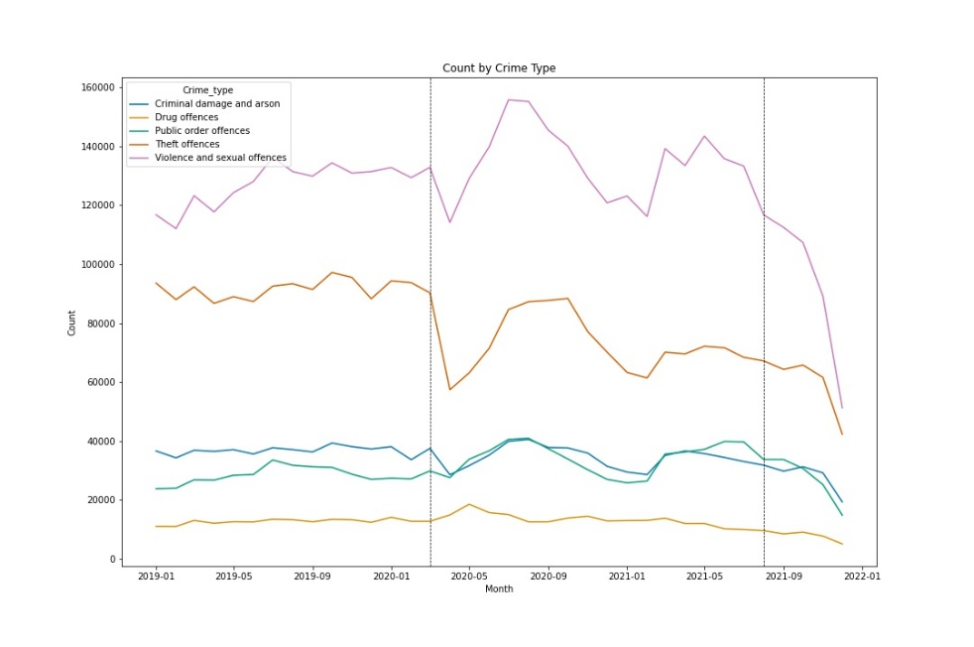

Figure 1 - Count by Crime Type

ARIMA:

Using data from 2017 to 2019, we can predict the expected crime rates of 2020 and 2021 (Fig 2). Using the historical data, is it easier to see consistent patterns such as in public order offences with the peaks and troughs from 2017 up to 2020. This makes it easier to see the effect of lockdown as we can not only identify anomalous patterns that occur from 2020 onwards but compare them to the predicted crime rates.

Starting with total crime, the initial drop of lockdown does fall outside of the 95% confidence interval of the prediction, stating a significant difference in what occurred and what was expected. It then rises up and stays within the predicted boundaries for the majority, apart from exiting it again briefly at the beginning of 2021. Both these significantly different points have occurred when lockdowns were announced, indicating a strong correlation between lockdowns and the initial reduction of crime rates.

When drilling down further into each respective crime type, we see more noticeable deviations. Criminal damage and arson follow a similar pattern to total crime, with two significant dips happening at the first lockdown and at the January 2021 lockdown. The prediction on this crime type appears slightly off however, with the 2017 to 2019 data containing a downward slope but the prediction rising. The ARIMA model may not have captured the trend so effectively on this crime type.

Public order offences and violence and sexual offences appear to have been impacted the least. Although violence does drop significantly during the initial lockdown, both crime types stay within the predicted range. This could be due to confounding variables, such as different types of violent crime or public order dropping but other types increasing to counteract the difference overall.

Both theft and drug offences have the greatest difference to their predictions. Theft sees the greatest drop at the beginning of lockdown putting it strongly out of the predicted range, whilst drug offences see a massive rise at the same period. Theft and drug offences do revert quickly to more stable levels during the summer of 2020, however all crime rates drop during the lockdown of early 2021, except for drugs which rises again before dropping steeply.

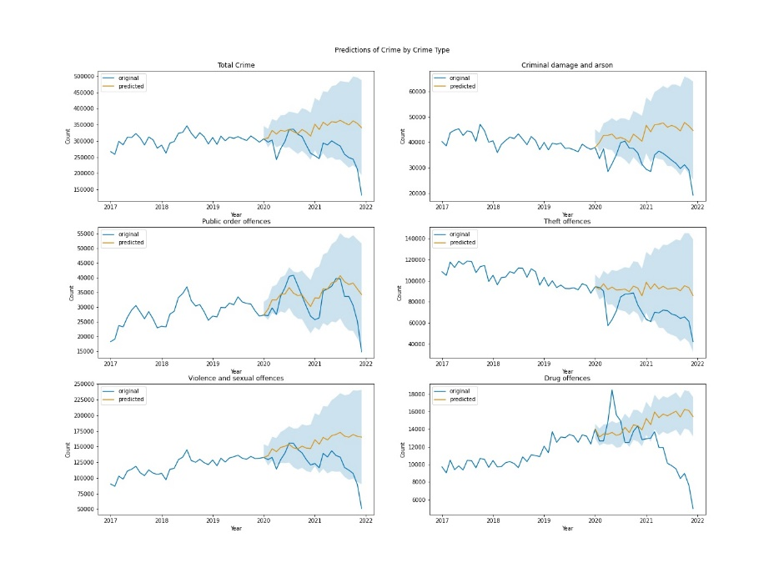

Regional Changes:

The changes in crime rate can also be examined regionally (Fig 3, Fig 4 & Fig 5). By normalising by 10,000 citizens, trends can be identified and the regions can be directly compared. All appear to follow a similar pattern during the coronavirus lockdowns, with an initial dip followed by a rise during the summer, then another large dip and another rise as lockdowns start to end during mid-2021. A notable difference between the regions that the West Midlands dips earlier and sharper at the end of 2020 in comparison to the rest of the regions. This could be related to the local lockdowns that some regions and cities (such as Leicester) implemented separately from the rest of the country. What is also interesting to note is the fact that population size does not appear to have an impact on crime. The population numbers used are in Table 2, the South East has more than double the population of the East Midlands yet only has 2/3 the crime per 10,000 citizens. Similarly, the North has approximately 1/6 the population of the South East but records higher crime per 10,000 citizens.

Figure 4 calculates the percentage change between each month and the same month of the year prior (for example, April 2020 compared to April 2019) for each crime type and region. All regions appear to follow the same pattern for each crime type, the noticeable difference being the South East following the same shape but shifted higher during the 2020 period. As this is percentage change, this indicates that the South East had a lower crime rate during 2019 compared to 2020 for all crime types. All regions and crime types follow the initial dip of April 2020, some like theft offences stay far lower than the previous year records whilst others such as public order offences & violence and sexual offences increase by up to 40% compared to the previous year. Drug offences sees the largest spike up to 70% increase in the South East. What is interesting to look at are the values at April 2021, as this is demonstrating the change between a year exactly after the lockdown. Every crime type and region spike upwards at this point, emphasising the sudden crime rate drop that occurred a year before.

Figure 5 repeats the above but instead calculates the percentage change to a median 2019 value for each crime type and region. This allows a comparison between both covid years of 2020 and 2021 to a non-covid year of 2019. Similar patterns are observed as in Fig 4 but the difference is that we can directly compare each month to an overall non-covid period. To demonstrate, after the initial bump for drug offences, we find that all regions drop down to approximate 2019 levels until March 2021, before dropping even further than previous non-covid levels. Again, the South East appears to have the greatest increase of crime compared to the other regions, especially within theft offences.

It is important to roll up at points when visualising this type of data. Fig 6 shows the actual counts of the crime types through the period. Whilst drug offences have a large spike in Fig 4 & Fig 5, the actual increase is only 20,000. It is clear to see that criminal damage, drug offences & public order offences don’t have as large raw changes as theft offences & violence and sexual offences, with those differing in the hundreds of thousands.

Outcomes:

The recorded levels of crime appear to have changed over the lockdown periods, however the outcomes regarding these arrests does not appear to have moved significantly. The highest change is within theft offences between 2019 and 2020, with an increase of 5% that there will be no suspect identified. This could be a result of less thefts occurring during covid (fig 6) as well as police resources being stretched thin to enforce lockdown, therefore theft crimes that may have usually been investigated would have not received the normal amount of attention.

Another change is noticed in drug offences, with ‘other outcomes’ rising by around 5% each year from 56% in 2019 to 65% in 2021. This difference comes directly opposite ‘suspect charged’ which decreases 5% each year. This is may be evidence of the police and the judicial system attempting to reduce drug crime using other methods such as rehabilitation programmes, rather than charging drug users which may not provide them with the help to kick their addiction. Drug crimes also include drug dealers which would be adequately charged and it is unlikely they would be given another outcome such as a caution or fine.

The outcomes can also be stratified by region. Not all regions have the same reaction to lockdowns being introduced, with the South East increasing the ‘no suspect identified’ from 47% in 2019 to 56% in 2020 whilst all other regions decrease in the same outcome. The difference for South East compared to the other regions could be related to the disproportionate increase of certain crimes such as theft offences as seen in Figures 4 & 5. As seen in Figure 7, it is known that theft offences have a high probability of no suspect being identified, therefore a high increase in theft offences for a given region may increase the overall probability of no suspect being identified.

The probability for a suspect to be charged also decreases for all regions from 2019 to 2021. Like in Fig 7, both ‘other outcome’ and ‘suspect charged’ are the minority probabilities, with only small changes occurring over the period, however each region has very similar ranges (approximately 5% to 10%) for both of these outcomes. This differs to the ranges of ‘no suspect identified’ and ‘unable to prosecute suspect’, with all regions having very different levels. For example, in 2020, the South East has a 56% probability of ‘no suspect identified’ whilst the South West has half this value at 28%. What this appears to show is that some regions are better overall at identifying suspects, but may lack the ability to actually prosecute them. This is evidenced by the fact that all regions have similar ‘suspect charged’ probabilities yet wildly varying ‘unable to prosecute suspect’ ranges. A number of factors could influence this such as the size of the region, the number of police officers as well as the public attitude towards police, each regions level of focus on different crime types and the prevalence of certain types of crime in each region.

Bayesian Network:

Firstly, a small network was learned on the data to investigate the relationships between the variables of region, lockdown level, crime type and outcome type (Fig 9). This provides a more interactive version of the data produced in figures 7 & 8. To keep the proportions the same, each year has been given its own level of lockdown, with 2019 being ‘No Lockdown’, 2020 being ‘High’ and 2021 being ‘Medium’. It is found that there is a higher probability of a public order offence occurring during 2020 and 2021, this could be due to the enforcement of lockdown restrictions as well as mask mandates leading to more public order disturbances. This method also allows us to investigate some of the minority probabilities (suspect charged and other outcome) that were seen in figures 7 & 8. When selecting these in ‘Outcome type’, we find that if a suspect is charged, it was most likely within 2020 (35.5%), in the South East (37.44% and for a violent or sexual offence (42.16%). Similarly, if ‘other outcome’ is selected, it is most likely to have occurred during 2019 (40.57%) and again within the South East (32.48%) for violent or sexual offences (40.7%). The model is available at: https://crimeduringcovid.staging.agenarisk.app/ Please email elliot.linsey@gmail.com to request access.

The larger Bayesian model is used to model the uncertainty regarding the true number of crimes committed versus the reported number of crimes. Using this model in combination with the prior knowledge allows us to estimate the true number of crimes within different covid periods. Table 3 records the rates (rounded to the nearest 1000) of actual and reported crimes during both lockdown and non-lockdown periods. The reported figures here are when the accuracy value is unknown, if we were to set the accuracy level for violence and sexual assaults to ‘maximal underestimate’ it would report 50% of the actual number of violent crimes, so approximately 132,000 would be reported.

Overall, the table and model are reporting the fact that both actual and reported crime increased in total over the coronavirus period, however some forms decreased such as theft & criminal damage and arson. The other three crime types of drugs, violence and sexual offences & public order offences increased over the lockdown period. This model is available to use at https://actualvsreportedcovidcrimes.staging.agenarisk.app/ please email elliot.linsey@gmail.com for access.

## Abbreviations and Acronyms

Define abbreviations and acronyms the first time they are used in the text, even after they have been defined in the abstract. Abbreviations such as IEEE, SI, MKS, CGS, sc, dc, and rms do not have to be defined. Do not use abbreviations in the title or heads unless they are unavoidable.

## Units

* Use either SI (MKS) or CGS as primary units. (SI units are encouraged.) English units may be used as secondary units (in parentheses). An exception would be the use of English units as identifiers in trade, such as “3.5-inch disk drive”.
* Avoid combining SI and CGS units, such as current in amperes and magnetic field in oersteds. This often leads to confusion because equations do not balance dimensionally. If you must use mixed units, clearly state the units for each quantity that you use in an equation.
* Do not mix complete spellings and abbreviations of units: “Wb/m2” or “webers per square meter”, not “webers/m2”. Spell out units when they appear in text: “. . . a few henries”, not “. . . a few H”.

Identify applicable funding agency here. If none, delete this text box.

* Use a zero before decimal points: “0.25”, not “.25”. Use “cm3”, not “cc”. (*bullet list*)

## Equations

The equations are an exception to the prescribed specifications of this template. You will need to determine whether or not your equation should be typed using either the Times New Roman or the Symbol font (please no other font). To create multileveled equations, it may be necessary to treat the equation as a graphic and insert it into the text after your paper is styled.

Number equations consecutively. Equation numbers, within parentheses, are to position flush right, as in (1), using a right tab stop. To make your equations more compact, you may use the solidus ( / ), the exp function, or appropriate exponents. Italicize Roman symbols for quantities and variables, but not Greek symbols. Use a long dash rather than a hyphen for a minus sign. Punctuate equations with commas or periods when they are part of a sentence, as in:

*a*  *b*    

Note that the equation is centered using a center tab stop. Be sure that the symbols in your equation have been defined before or immediately following the equation. Use “(1)”, not “Eq. (1)” or “equation (1)”, except at the beginning of a sentence: “Equation (1) is . . .”

## Some Common Mistakes

* The word “data” is plural, not singular.
* The subscript for the permeability of vacuum **0, and other common scientific constants, is zero with subscript formatting, not a lowercase letter “o”.
* In American English, commas, semicolons, periods, question and exclamation marks are located within quotation marks only when a complete thought or name is cited, such as a title or full quotation. When quotation marks are used, instead of a bold or italic typeface, to highlight a word or phrase, punctuation should appear outside of the quotation marks. A parenthetical phrase or statement at the end of a sentence is punctuated outside of the closing parenthesis (like this). (A parenthetical sentence is punctuated within the parentheses.)
* A graph within a graph is an “inset”, not an “insert”. The word alternatively is preferred to the word “alternately” (unless you really mean something that alternates).
* Do not use the word “essentially” to mean “approximately” or “effectively”.
* In your paper title, if the words “that uses” can accurately replace the word “using”, capitalize the “u”; if not, keep using lower-cased.
* Be aware of the different meanings of the homophones “affect” and “effect”, “complement” and “compliment”, “discreet” and “discrete”, “principal” and “principle”.
* Do not confuse “imply” and “infer”.
* The prefix “non” is not a word; it should be joined to the word it modifies, usually without a hyphen.
* There is no period after the “et” in the Latin abbreviation “et al.”.
* The abbreviation “i.e.” means “that is”, and the abbreviation “e.g.” means “for example”.

An excellent style manual for science writers is [7].

# Using the Template

After the text edit has been completed, the paper is ready for the template. Duplicate the template file by using the Save As command, and use the naming convention prescribed by your conference for the name of your paper. In this newly created file, highlight all of the contents and import your prepared text file. You are now ready to style your paper; use the scroll down window on the left of the MS Word Formatting toolbar.

## Authors and Affiliations

**The template is designed for, but not limited to, six authors.** A minimum of one author is required for all conference articles. Author names should be listed starting from left to right and then moving down to the next line. This is the author sequence that will be used in future citations and by indexing services. Names should not be listed in columns nor group by affiliation. Please keep your affiliations as succinct as possible (for example, do not differentiate among departments of the same organization).

### For papers with more than six authors: Add author names horizontally, moving to a third row if needed for more than 8 authors.

### For papers with less than six authors: To change the default, adjust the template as follows.

#### Selection: Highlight all author and affiliation lines.

#### Change number of columns: Select the Columns icon from the MS Word Standard toolbar and then select the correct number of columns from the selection palette.

#### Deletion: Delete the author and affiliation lines for the extra authors.

## Identify the Headings

Headings, or heads, are organizational devices that guide the reader through your paper. There are two types: component heads and text heads.

Component heads identify the different components of your paper and are not topically subordinate to each other. Examples include Acknowledgments and References and, for these, the correct style to use is “Heading 5”. Use “figure caption” for your Figure captions, and “table head” for your table title. Run-in heads, such as “Abstract”, will require you to apply a style (in this case, italic) in addition to the style provided by the drop down menu to differentiate the head from the text.

Text heads organize the topics on a relational, hierarchical basis. For example, the paper title is the primary text head because all subsequent material relates and elaborates on this one topic. If there are two or more sub-topics, the next level head (uppercase Roman numerals) should be used and, conversely, if there are not at least two sub-topics, then no subheads should be introduced. Styles named “Heading 1”, “Heading 2”, “Heading 3”, and “Heading 4” are prescribed.

## Figures and Tables

#### Positioning Figures and Tables: Place figures and tables at the top and bottom of columns. Avoid placing them in the middle of columns. Large figures and tables may span across both columns. Figure captions should be below the figures; table heads should appear above the tables. Insert figures and tables after they are cited in the text. Use the abbreviation “Fig. 1”, even at the beginning of a sentence.

1. Table Type Styles

| Table Head | Table Column Head | | |
| --- | --- | --- | --- |
| Table column subhead | Subhead | Subhead |
| copy | More table copya |  |  |

1. Sample of a Table footnote. (*Table footnote*)
2. Example of a figure caption. (*figure caption*)

Figure Labels: Use 8 point Times New Roman for Figure labels. Use words rather than symbols or abbreviations when writing Figure axis labels to avoid confusing the reader. As an example, write the quantity “Magnetization”, or “Magnetization, M”, not just “M”. If including units in the label, present them within parentheses. Do not label axes only with units. In the example, write “Magnetization (A/m)” or “Magnetization {A[m(1)]}”, not just “A/m”. Do not label axes with a ratio of quantities and units. For example, write “Temperature (K)”, not “Temperature/K”.

##### Acknowledgment *(Heading 5)*

The preferred spelling of the word “acknowledgment” in America is without an “e” after the “g”. Avoid the stilted expression “one of us (R. B. G.) thanks ...”. Instead, try “R. B. G. thanks...”. Put sponsor acknowledgments in the unnumbered footnote on the first page.

##### References

The template will number citations consecutively within brackets [1]. The sentence punctuation follows the bracket [2]. Refer simply to the reference number, as in [3]—do not use “Ref. [3]” or “reference [3]” except at the beginning of a sentence: “Reference [3] was the first ...”

Number footnotes separately in superscripts. Place the actual footnote at the bottom of the column in which it was cited. Do not put footnotes in the abstract or reference list. Use letters for table footnotes.

Unless there are six authors or more give all authors’ names; do not use “et al.”. Papers that have not been published, even if they have been submitted for publication, should be cited as “unpublished” [4]. Papers that have been accepted for publication should be cited as “in press” [5]. Capitalize only the first word in a paper title, except for proper nouns and element symbols.

For papers published in translation journals, please give the English citation first, followed by the original foreign-language citation [6].

1. G. Eason, B. Noble, and I. N. Sneddon, “On certain integrals of Lipschitz-Hankel type involving products of Bessel functions,” Phil. Trans. Roy. Soc. London, vol. A247, pp. 529–551, April 1955. *(references)*
2. J. Clerk Maxwell, A Treatise on Electricity and Magnetism, 3rd ed., vol. 2. Oxford: Clarendon, 1892, pp.68–73.
3. I. S. Jacobs and C. P. Bean, “Fine particles, thin films and exchange anisotropy,” in Magnetism, vol. III, G. T. Rado and H. Suhl, Eds. New York: Academic, 1963, pp. 271–350.
4. K. Elissa, “Title of paper if known,” unpublished.
5. R. Nicole, “Title of paper with only first word capitalized,” J. Name Stand. Abbrev., in press.
6. Y. Yorozu, M. Hirano, K. Oka, and Y. Tagawa, “Electron spectroscopy studies on magneto-optical media and plastic substrate interface,” IEEE Transl. J. Magn. Japan, vol. 2, pp. 740–741, August 1987 [Digests 9th Annual Conf. Magnetics Japan, p. 301, 1982].
7. M. Young, The Technical Writer’s Handbook. Mill Valley, CA: University Science, 1989.

We suggest that you use a text box to insert a graphic (which is ideally a 300 dpi TIFF or EPS file, with all fonts embedded) because, in an MSW document, this method is somewhat more stable than directly inserting a picture.

To have non-visible rules on your frame, use the MSWord “Format” pull-down menu, select Text Box > Colors and Lines to choose No Fill and No Line.